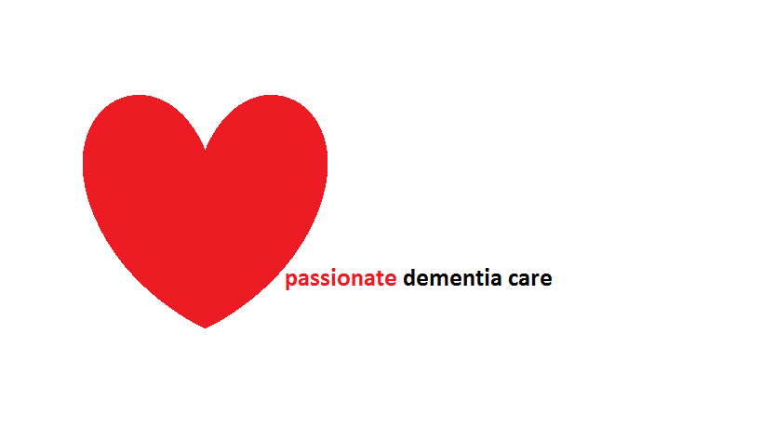

Churches Inc – for people with dementia

God made everyone with dementia in His image and equally valuable

It is estimated that there are over 750,000 people with dementia in the UK and the number is expected to rise to 1.5 million by 2040. Dementia is the name given to a collection of diseases that impair people’s ability to remember, think, and make choices. Having a dementia is like having any other disability such as blindness or deafness. Much can be done by others and the wider community to minimise the effect of dementia and maximise people’s ability to maintain independence.

Being human is not based on people’s ability to remember, think and make choices, but rather that they reflect the image of God. This means that everyone displays, in part, what God is like. This includes God’s creativity, capacity to make purposefulness, and ability to enter into relationships. In addition, God took the form of a body in Jesus Christ and thus gave the body respect and dignity as a ‘temple’ of God’s spirit.

Jesus called us to love people that society overlooks and excludes

Until recently people with dementia were taken away from their family and local community and placed in long stay institutions. Often they found themselves isolated, having few visits from relatives and friends. They were frequently given little respect and dignity, which left them feeling as though they were no longer people and easily ignored and discounted. Sometimes people with dementia were emotionally and physically abused.

Jesus was concerned with promoting the health and well-being of all people, including people with dementia. Through his words and actions, Jesus showed marginalised people compassion and love, gave them a new life, and enabled them to return to the community. People who follow Jesus will treat people with dementia in the same way and will include them in their mission.

Without disabled people and their gifts, our church is incomplete The Bible sees the church as being like a body in which every part has a role that helps and supports the rest of the body. Every follower of Jesus, including people who have dementia, has gifts which they can share with others. In a society that highlights social success and personal intelligence, people with dementia offer a challenge that reminds us of our fragility and dependence on others, and on God. People with dementia will have retained gifts and abilities and will be able to share these with to support others. Churches need to display humility and be willing to receive what people with dementia have to offer. Having dementia makes people no less than those without dementia. Without people with dementia, the church is incomplete and cannot gain from their experience and journey as it seeks to fulfil Jesus’ mission to the world.

So we will…

Act to make our church an increasingly accessible place
- Say ‘hello’ to everyone, including people with dementia when they attend church events
- offer activities in areas of the church that are well lit, warm and comfortable
- People with dementia use the same things - crockery, communion vessels and toilets - as other church members
- Ensure that toilet and washing areas are always kept clean
- Train church members to understand, value and communicate effectively with people who have dementia
- Have a structured and systematic approach to visiting people with dementia who may not able to attend church activities, whether they live at home or in a care home
- Develop a tolerant and sensitive approach towards people with dementia who break accepted rules about how to behave

Encourage our church to make its activities more inclusive
- Never exclude any person with dementia from any church activity that is open to the public
- Offer communion to all people with dementia, irrespective of their ability to think and remember
- Look for strengths and abilities in people with dementia that will promote creativity and their contribution to others
- Invite and support people with dementia to take part in activities they are able to do and which make them visible
- Use familiar Christian songs that they may have learnt a long time ago
- Ensure that one or more song during worship uses basic language and straightforward ideas
- Sermons to last no more than ten minutes when people with dementia are present
- Use symbolism – items such as vestments and candles may help people with dementia to remember
- Encourage people with dementia to go up for prayer
- Use touch - shaking hands as a sign of peace and shared fellowship
- Develop special services for people with dementia and carers

Welcome and build community life with disabled people
- Work with others in the local community on issues that promote the well-being of people with dementia and their family carers and offers them the hope of justice
- Offer workshops and other activities that promote people’s awareness of dementia
- Offer training and support for family carers
- Develop and support church-based activities that support family members such as a relative support group
- Offer a listening and information provision for sharing service for people with dementia and their family members
- Develop a prayer ministry for people with dementia and their families
- Designate a special Sunday as ‘Dementia Sunday’

Based on the Churches Inc charter developed by Livability and Through the Roof. For more information visit www.churchesinc.org.uk
Livability is creating choices for disabled people, transforming communities and fighting injustice. They love to help churches welcome disabled people.
Email churchesinc@livability.org.uk

